DEPARTMENT OF LINGUISTICS
SOUTHERN FEDERAL UNIVERSITY, TAGANROG, RUSSIA

Dear colleagues,
It is our great pleasure to invite you to participate in the
4th International Conference
LINGUISTICS, LANGUAGE TEACHING AND INTERCULTURAL COMMUNICATION: THEORY AND PRACTICE (LLTIC 2017)

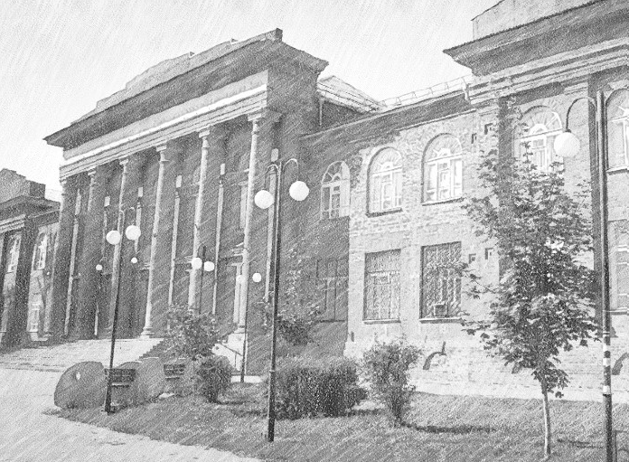

Conference date: | May 24-27, 2017
Conference venue: | Southern Federal University, per. Nekrasovskiy, 44,  Taganrog, Russia
Official languages: | English, Russian
Written papers to be submitted in: | English
Conference fee: | free of charge for the foreign participants
Topics: | - Linguistics and Language Research  - Innovative Language Teaching and Learning  - Translation and Translation Studies  - Russian as a foreign language: problems and solutions  - Language testing: yesterday, today and tomorrow
Types of Presentation: | A Plenary session report: 30 minutes for presentation, with 10 minutes for discussion  A conference presentation: 10 minutes for presentation, with 5 minutes for discussion  A video presentation: 10 minutes for presentation. For the on-line format: 5 minutes for discussion
Deadlines: | 24 April: registration and submission of abstracts.  10 May: abstract acceptance notification.  21 May: conference programme will be announced
Registration: | Please see Attachment 1 for the application form. Fill in the application form, save it as ‘R-your surname’ (e.g. R-Smith), and submit it by 24 April 2017 at privalova@tti.sfedu.ru
Full text paper: | Please see Attachment 2 for the Guidelines for Abstract Formatting and the template. Save your abstract as ‘A-your surname’ (e.g. A-Smith) and submit no later than 24 April 2017 at privalova@tti.sfedu.ru
Travel expenses: | Must be paid by the participants. Please inform beforehand if you need a visa
Transfer to and from Rostov-on-Don Airport: | Provided for free
Accommodation: | Provided for free. Participants can also make their own arrangements for accommodation in the local hotels.

We look forward to welcoming you here in Taganrog in May!

Best regards,

General Chair:
Julia Privalova, privalova@tti.sfedu.ru
tel. +79081827462

Organizing Committee Chair:
Svetlana Baluyan, sbaluyans@sfedu.ru

PS.: We kindly ask you to spread the word about our conference among colleagues.

Attachment 1

4th International Conference
LINGUISTICS, LANGUAGE TEACHING AND INTERCULTURAL COMMUNICATION: THEORY AND PRACTICE

Registration Form

Please fill in the registration form, save it as ‘R-your surname’ (e.g. R-Smith) and send by e-mail before 24 April 2017 to privalova@tti.sfedu.ru

First Name:

Last Name:

Institution:

Job Title / Position:

Address:

E-mail:

Telephone: Mobile:

Title of the presentation/contribution:

Special Requirements:

Accompanying persons:

Attachment 2

4th International Conference
LINGUISTICS, LANGUAGE TEACHING AND INTERCULTURAL COMMUNICATION: THEORY AND PRACTICE

Guidelines for the Abstact

Text Editor | Microsoft Word
Font | Times New Roman 14pt
Line Spacing | 1.5
Margins | 2 cm all sides
Alignment | Wide
Paragraph Indention | 1.25 cm
Paper Title | Centered in block capitals, bold
Author’s Name(s) | Upper left-hand corner, in italics, bold
Institution, Country | Under the academic degree line
Author’s e-mail | Under the institution
Text volume | Up to 1500 characters with spaces

Abstract Template

ICT IN LANGUAGE TEACHING

Ivan Ivanov
Southern Federal University, Russia
ivanivanov@sfedu.ru

Using ICT in foreign language learning and teaching environment enables students to become more motivated in …

